User manual Anomaly detection / aggregation

Purpose
Detection of anomalous values in NDVI time series. An anomalous value is determined as follows:
- Spatial filtering by class (from a second input file)
- Extracting valid ranges from a table with the class as key
- Anomalous values are outside this valid range.
Furthermore the software has different options to aggregate / summarize the anomalies.

Installation
Install the .sav files in the save_add folder (see also ENVI .sav files: Installation and configuration.
anomaly_gui.sav The anomaly detecting software
nrs_utils.sav Utility routines

Usage (GUI)
Starting is possible from the command line:
anomaly_GUI
, or from the ENVI menu ‘NRS | detect NDVI Anomalies’, which starts a dialog with three tab-pages (see below):
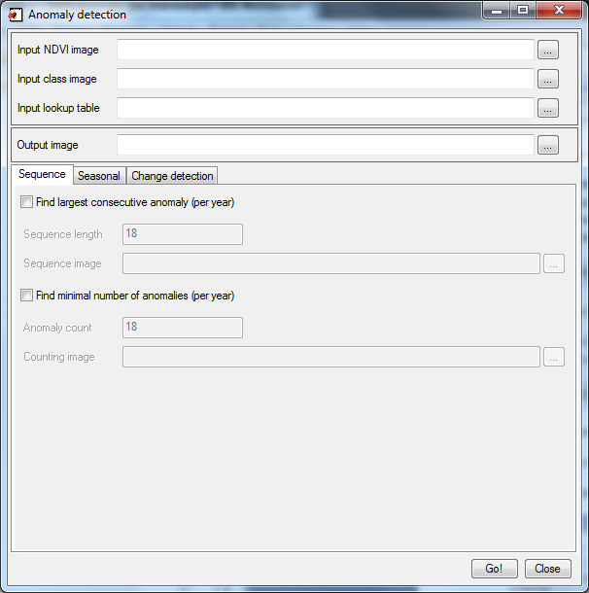 | 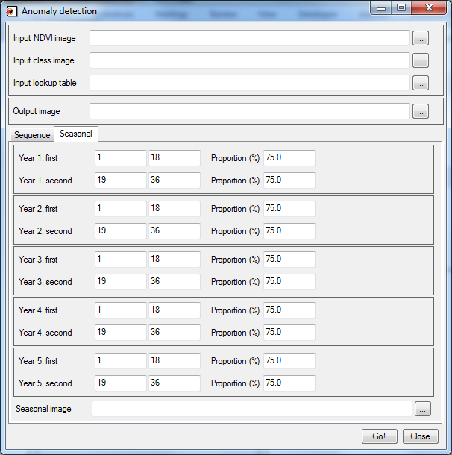 | 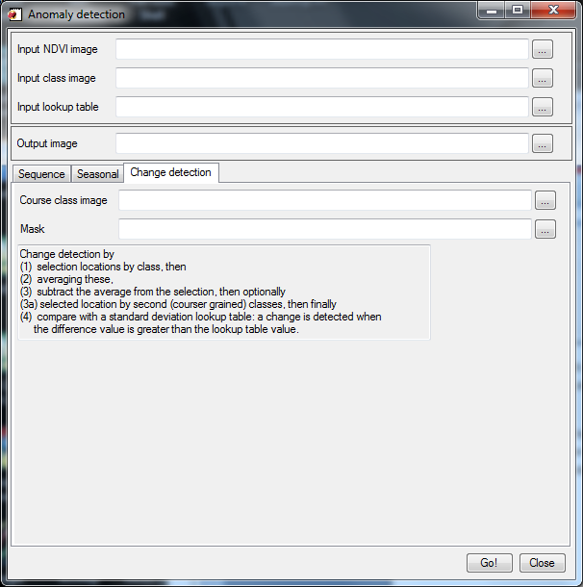
The dialog consists of an input section, an output section and aggregate / summarizes sections in separate tab-pages: sequence, seasonal and change detection.
The input section has fields to enter the input NDVI stack, the classified image and the table with the value ranges. This section can be left blank, allowing the software to calculate the aggregation options without recalculating the anomalies. The output section then becomes the input field.
The output section contains one field to enter the name of the anomaly output. This section can also be used to specify the input for the aggregation options (originally calculated with the input section filled in)
The sequence section contains fields to manipulate the aggregation behavior (yearly). There are two options:
1. Find largest consecutive anomaly: if enabled, aggregation is calculated: for each year of NDVI observations the longest consecutive sequence of anomalies is calculated. This is compared with the sequence length field, and if the sequence is longer than or equal the output for that year becomes one, otherwise zero.
2. Find minimal number of anomalies: if enabled simply count the number of anomalies per year, and if larger or equal to the anomaly count field the output for that year becomes one, otherwise zero.
The seasonal section contains fields to find anomalies in two seasons per year. In each season the user can indicate a shorter period to find the anomalies. Aggregation now indicates anomalous behavior when the indicated period contains more than a user specified proportion of anomalies. Default for the period is the entire period, for the proportion 75%. As an example:
Year one, season one contains 11 anomalies, but the period 4 to 15 contains 10
1 | 2 | 3 | 4 | 5 | 6 | 7 | 8 | 9 | 10 | 11 | 12 | 13 | 14 | 15 | 16 | 17 | 18
0 | 0 | 0 | 1 | 1 | 0 | 1 | 1 | 1 | 1 | 1 | 1 | 1 | 0 | 1 | 1 | 0 | 0
For the entire period: Anomaly = (11 / 18) > 0.75 = 0.61 > 0.75 = no
For the selected period: Anomaly = (10 / 12) > 0.75 = 0.831 > 0.75 = yes
The change detection section contains fields to configure the change detection, as well as an explanation on the algorithm; no extra input is required. Change detection runs in several possible ways:
1. The magnitude output field is filled in: Select locations based on the input class image field, then (for the selection locations only) average the values in each layer, find the difference with the actual values and determine a change when the difference is larger than the threshold value (standard deviation calculated externally) from the lookup table. Output both the change detection as well as the absolute difference between the actual value and the average ± the standard deviation.
2. The Course class image field is empty: Select locations based on the input class image field, then (for the selection locations only) average the values in each layer, find the difference with the actual values and determine a change when the difference is larger than the threshold value (standard deviation calculated externally) from the lookup table.
3. The Course class image field contains a second classified image with course grained classes. The first classified image should contain fine grained classes (much more different classes). The first phase now calculates the differences from the average (as explained above in option 1), but the lookup is done by selecting from the second classified map.
After either option a mask can optionally be applied to remove unwanted locations.
Running the calculations will display progress bars to indicate the progress visually:
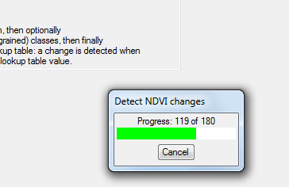

Scenarios
Only calculate anomalies  (figure 1) | Specify input and output section fields, activate the sequence tab-page and disable sequence finding
Only calculate sequences  (figure 2) | Leave input section blank, specify output section (with anomalies), activate sequence tab-page, enable sequence finding and specify section fields
Only calculate seasonal  (figure 3) | Leave input section blank, specify output section (with anomalies), activate seasonal tab-page and specify section fields
Calculate anomalies and sequences  (figure 4) | Specify input and output section fields, activate sequence tab-page, enable sequence finding and specify section fields
Calculate anomalies and seasonal  (figure 5) | Specify input and output section fields, specify output section (with anomalies), activate seasonal tab-page and specify section fields
Calculated change detection  (figure 6) | Specify input and output section fields, activate the change detection tab-page, and leave fields on this page empty
Calculate 2-phase change detection  (figure 7) | Specify input and output section fields, activate the change detection tab-page, and specify the second classified image
Calculate 1-phase change detection, with magnitude output (figure 8) | Specify input and output section fields, activate the change detection tab-page, and specify the output magnitude image

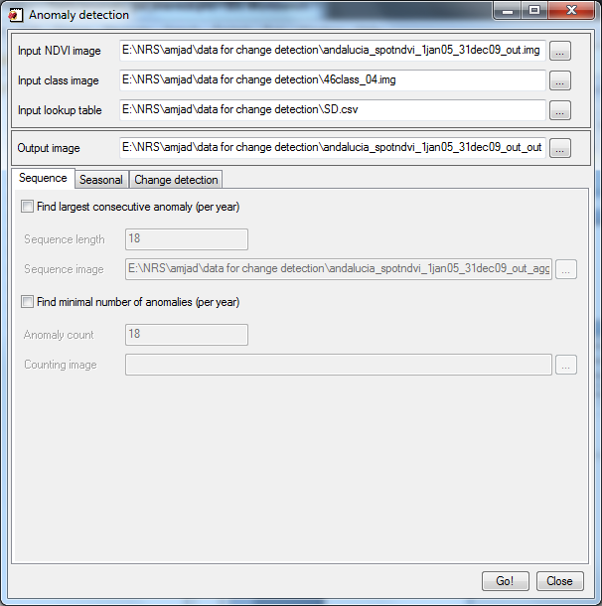
Figure 1: Calculate anomalies only
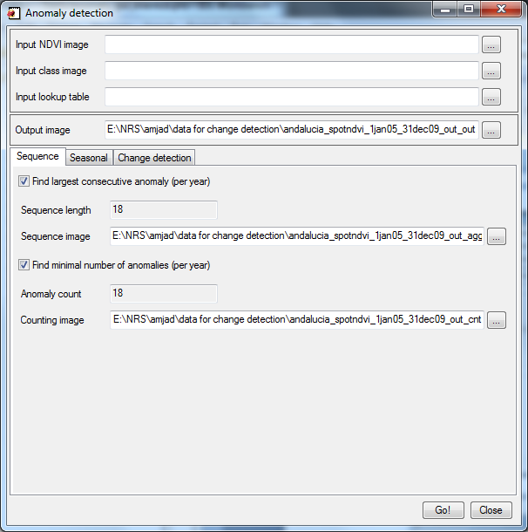
Figure 2: Calculate only sequences
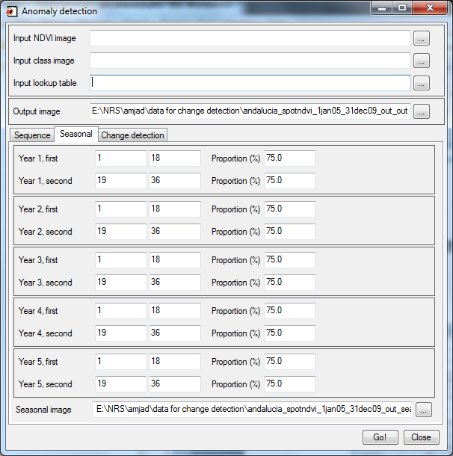
Figure 3: Calculate only seasonal aggregation
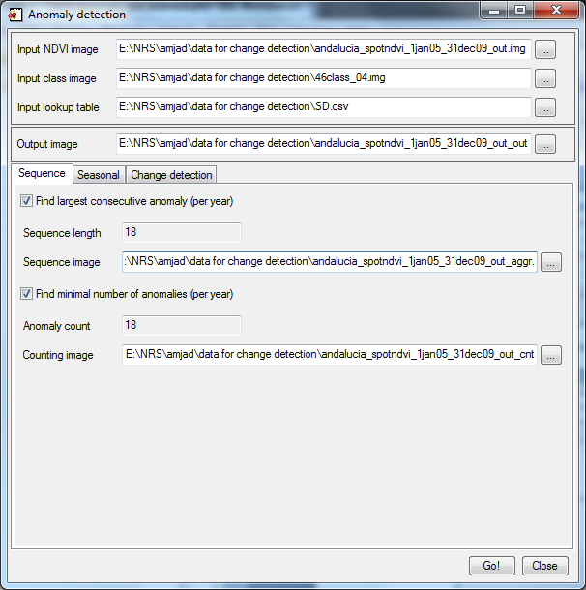
Figure 4: Calculate anomalies and sequences
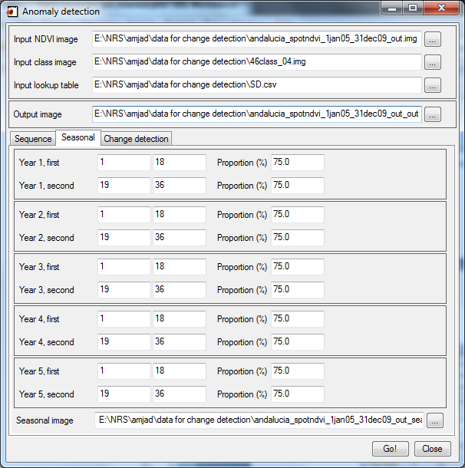
Figure 5: Calculate anomalies and seasonal aggregation
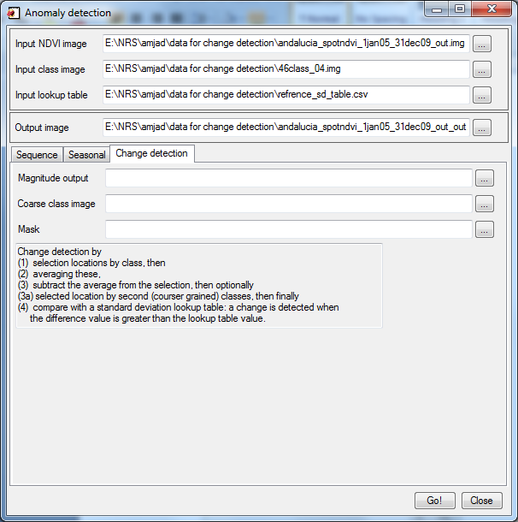
Figure 6: Calculate 1-phase change detection
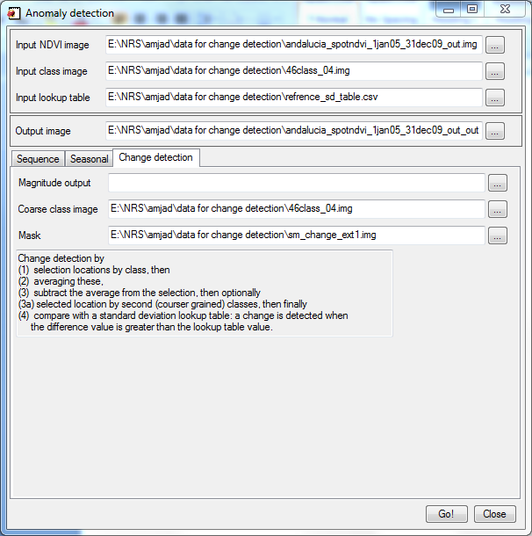
Figure 7: Calculate 2-phase change detection
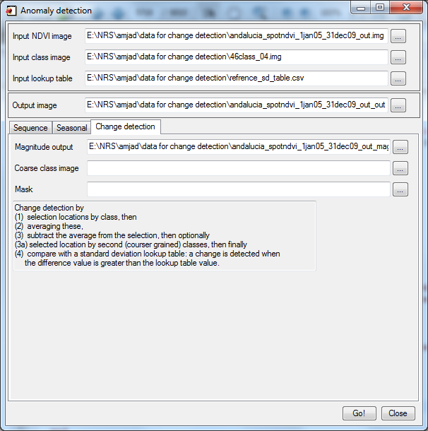
Figure 8: Calculate 1-phase change detection, with magnitude output

